REPORT
To:Elvin Bahali
From: Carolina Marta
Date: 4th April 2022
Subject: Report on coordinators' meeting
Introduction
This report evaluates the development of the international meeting held in Seixal – Portugal from 27/03/2022 – 02/04/2022, of the Erasmus+ KA229 Strategic Partnership Project “THINK GREEN GO GREEN & RECYCLE FOR LIFE” between Turkey, Portugal, Spain and Italy.
The evaluation process aims to analyze the whole planning of the meeting and its development, according to the general lines of the project and to the partners’ agreements about basic characteristics of each meeting in order to guarantee minimum standards of quality for activities and outcomes.

These activities are set up by international working groups, with mixed students from different countries, promoting the in-depth exchange of ideas and cultures around a common language: English, and a common idea: to draw attention to environmental problems and agriculture of the future.

The main methodology used in the implementation of the project was learning by doing. All the planned activities are developed for students to gain first-hand experiences. Besides, questionnaires to be applied, focus group meetings, exploration visits, classroom applications and evaluations will be the other methodologies to be used.
From the analysis of the activities program of the meeting, organization of the groups and workshops, presentations and outcomes obtained, we can conclude that this mobility has been a success, which is adapted to the project implementation plan, and will contribute to achieving the objectives outlined in it. To quantify the quality of the development of the meeting, the adjustment to the implementation plan of the project and the expected outcomes, and in the impact on participants’ partner institutions, evaluation questionnaires have been filled by all participants at the end of the meeting.

Activities
Day 1
On the first day of activities, we had several activities: the opening ceremony of the project and a school tour. After lunch, all participants presented their country, city, and school and ended up with a general culture game about recycling and vermicomposting.

Day 2
The second day was dedicated to the environment and the future of agriculture - Hydroponics. First, the students attended a workshop on traditional farming methods, greenhouses, vermicomposting, and hydroponics. In this workshop (located in the greenhouse), students learned about plants, seed germination, aromatic plants, vermicomposting, and hydroponics, where they had the opportunity to plant lettuces in a hydroponic method. In the afternoon, in groups, students were able to make a poster to alert people to environmental issues. They have used different digital applications, and the posters will be published on the website.
Day 3
On the third day in Portugal, all participants took a city tour in Lisbon. Knowing the culture and way of life of the Portuguese people is always a good way to welcome all students and teachers.

Day 4
On the 4th day, the students and teacher made a visit to the Science Museum in Lisbon, a museum dedicated to the sciences (in the permanent exhibition) and with a temporary exhibition on the importance of water. During the afternoon, the teachers had the opportunity to learn the farming methods of a traditional vineyard.

Day 5
On the last day, students had the opportunity to hold a workshop on maritime pollution (oil spills). The teachers' meeting also took place.
In the evening, all attended the dinner and the closing ceremony and distribution of the certificates.
Despite all the challenges in holding the meeting due to covid 19, all activities went as planned.

EVALUATION

Organization

All students and teachers completed the evaluation questionnaire. The results, on the whole, are very satisfactory because in most items they rated the development of the meeting and the project with very high marks.

In the evaluation questionnaire the participating students and teachers were asked to rate different items in these areas: organization of the mobility and specific workshops and cultural activities; and host families.

Participants were asked to rate from one to five (1= worst rating, 5= best rating)

According to the implementation plan, each partner school provided students with preparation in order to get a successful meeting.
Good collaboration among different participants in the work team is key to guaranteeing a successful result. This is not an easy element to achieve if we take into account the different profiles of students, different ages and characters, different countries of origin, different languages, etc., all of them working around a common project and with the aim of showing a good result at the end of the week.

LTT activities organization
In the evaluation questionnaire, the participating students and teachers were asked to rate the quality of the result of the workshops, in terms of if they considered these activities to accomplish their expectations, if they enjoyed them and how much did they learn. We consider this assessment very important, as it can influence the design of tasks in coming meetings and workshops. As shown in the graph, workshops have been well rated by participants. The participating teachers also had to work as teachers to evaluate the quality of the final results of this meeting, with special emphasis on the work carried out by the participants in the workshops of the week.

Welcome Ceremony

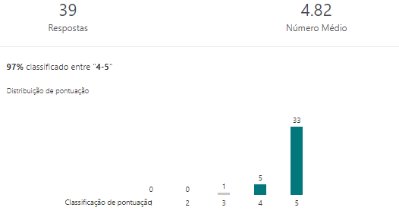

School/ Country Presentation and Kahhot Game

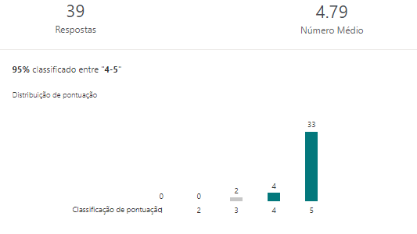

Workshop (Hydroponics, Worms, and Plants) in Greenhouse

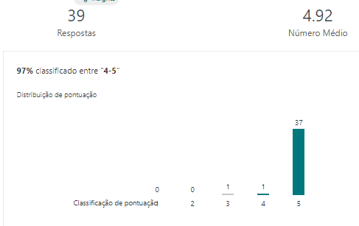

Poster Workshop

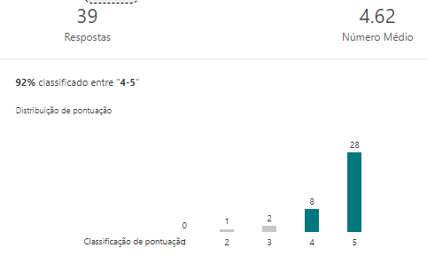

Science Museum Visit

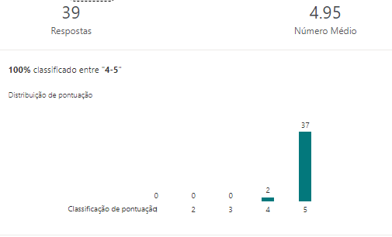

Water pollution workshop

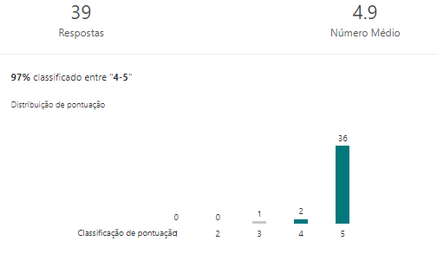

Farwell party
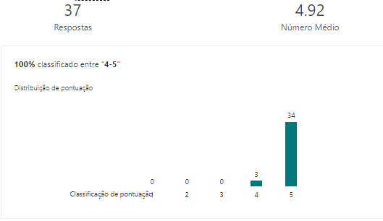

Lisbon Story Center and Lisbon Tour

Cultural activities organization Cultural and leisure activities during the week of the meeting contribute to improving the work and collaboration. As shown in the graph, cultural activities have been well rated by participants.

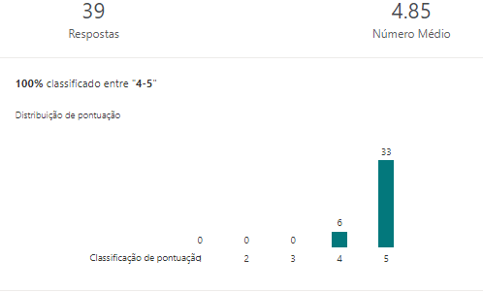

Staying conditions Also the conditions of the stay: - meals offered, timetable, transfers accommodation- is an element that we must evaluate in order to detect possible dysfunctions and introduce, if necessary, the corrective measures; therefore, we also ask the students and teachers about this matter, and in view of their answers we can conclude that the quality stay conditions has been good or very good for almost all participants.

Hosting Families
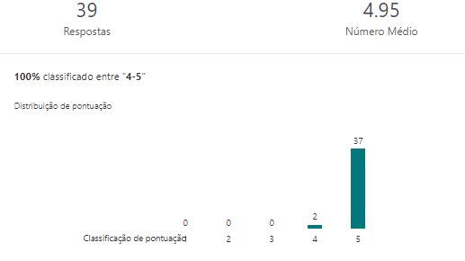

School Staff Hospitality

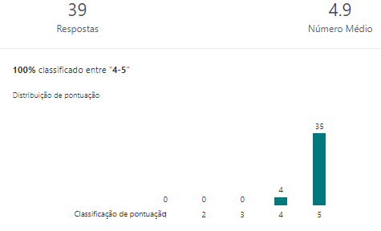

School Meals
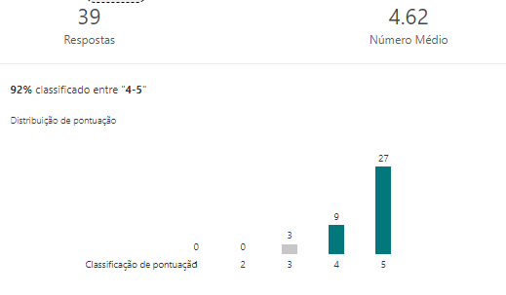

Accommodation

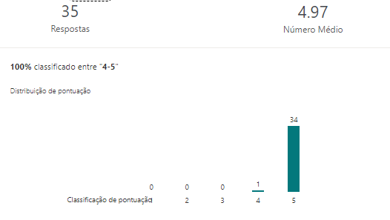

Transportation

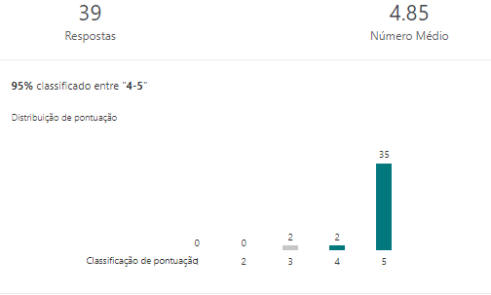

Overall
Evaluation – 4.85 points

The evaluation questionnaire also included open questions in which students and teachers could express their opinion about the meeting and the project in general. So asked for their impression about the meeting, the students expressed very diverse comments, showing in their answers satisfaction for a good experience during this week:
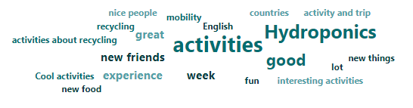

To sum up, we believe that the involvement and collaboration among all participants teachers and staff, visitors, and the locals, it is fundamental for a successful meeting. From the evaluation made, we can conclude that the meeting was a success; however, over time, we will be able better to evaluate the impact of all activities on our students. I hope that all activities will contribute to a greener planet and the growth of our students as part of a planet where environmental problems are on the agenda.

Signatures

__________________ ___________________
Carolina Marta Elvin Bahali

